**Github repo-link-** [**link to github hr-dashboard repo**](https://github.com/lisarikalluri/hr-dashboard)

**💼 HR DASHBOARD(ADVANCED)-TASK-1**

**OUTPUTS:**

**->login page:**  
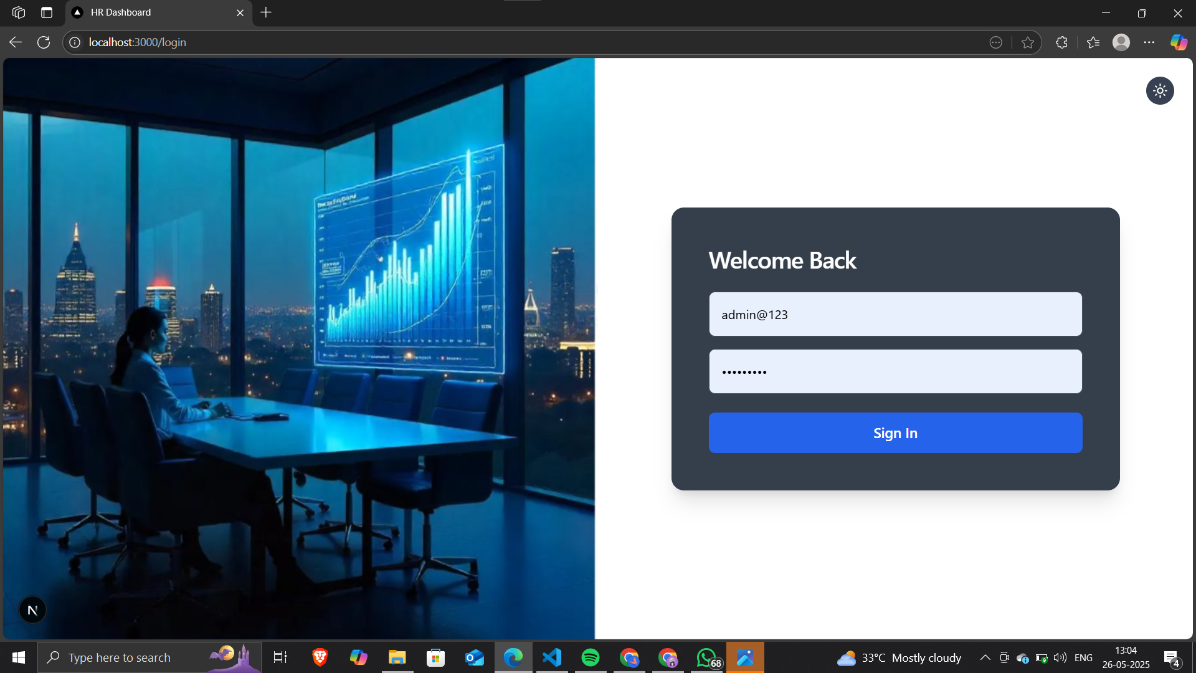**->Home page:**  
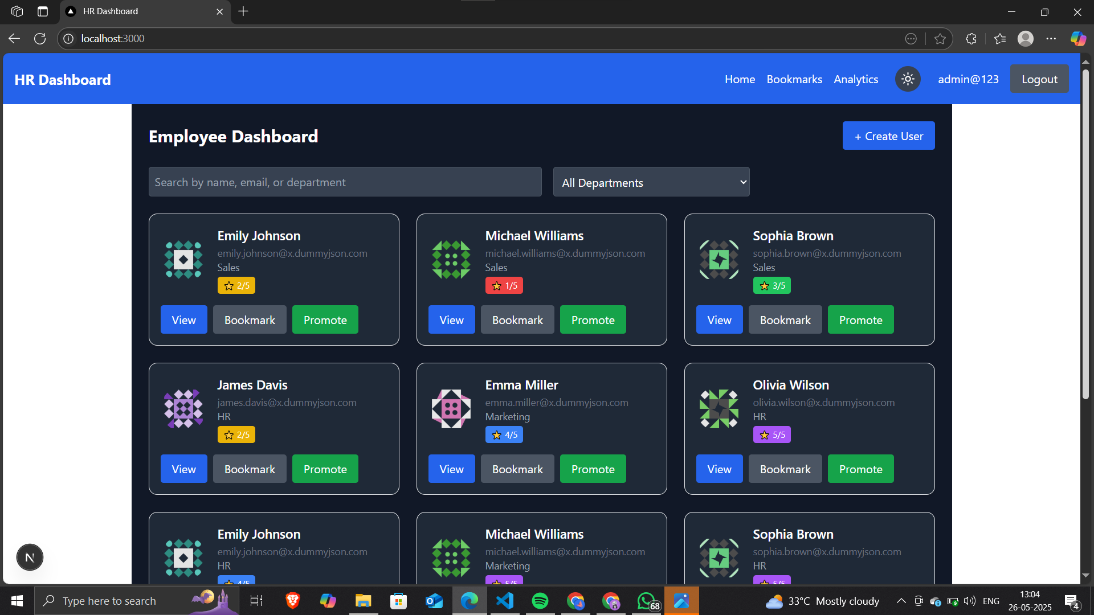

**->Create user:**

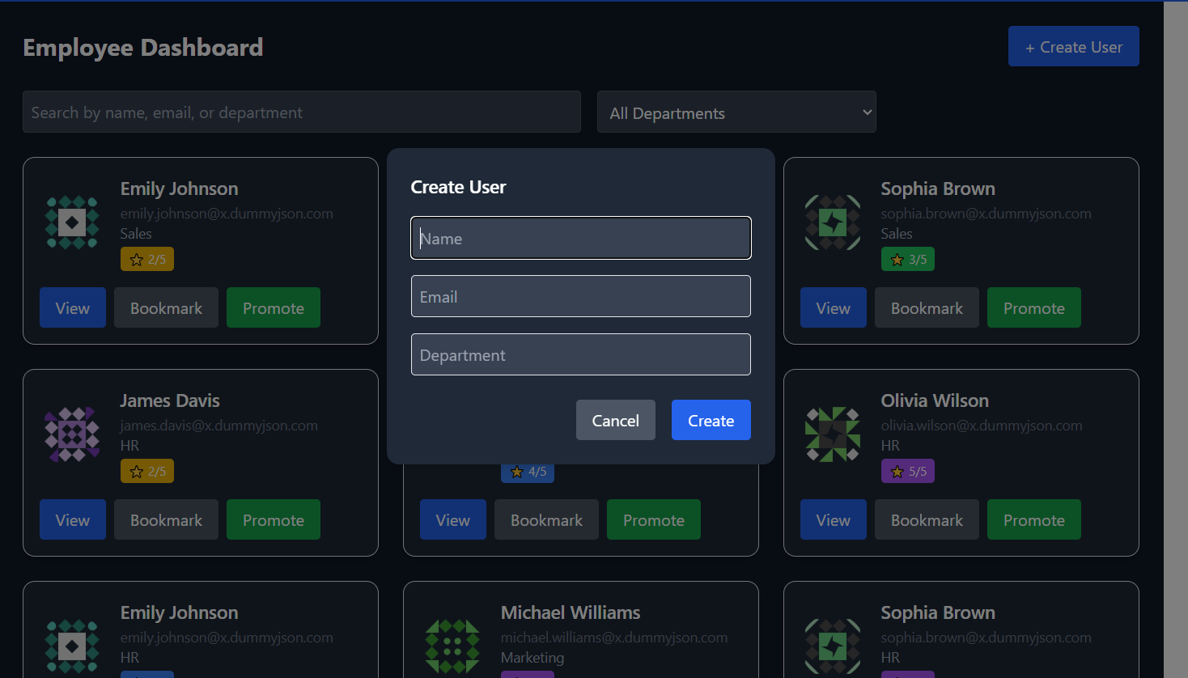

->Bookmark page:

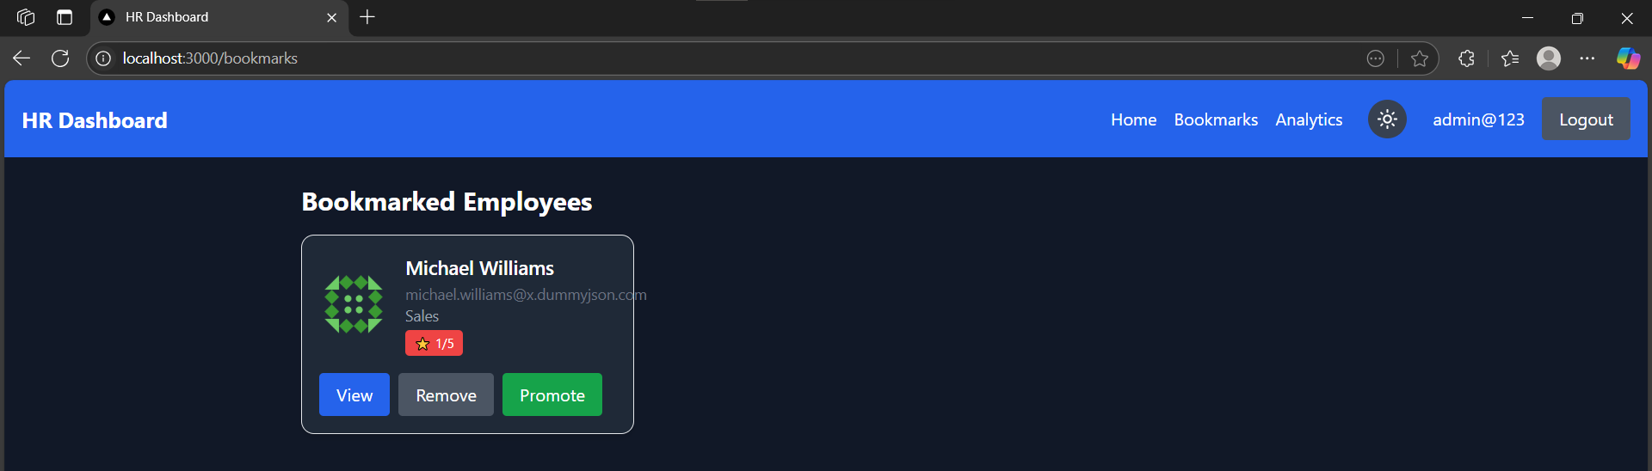

->view page:

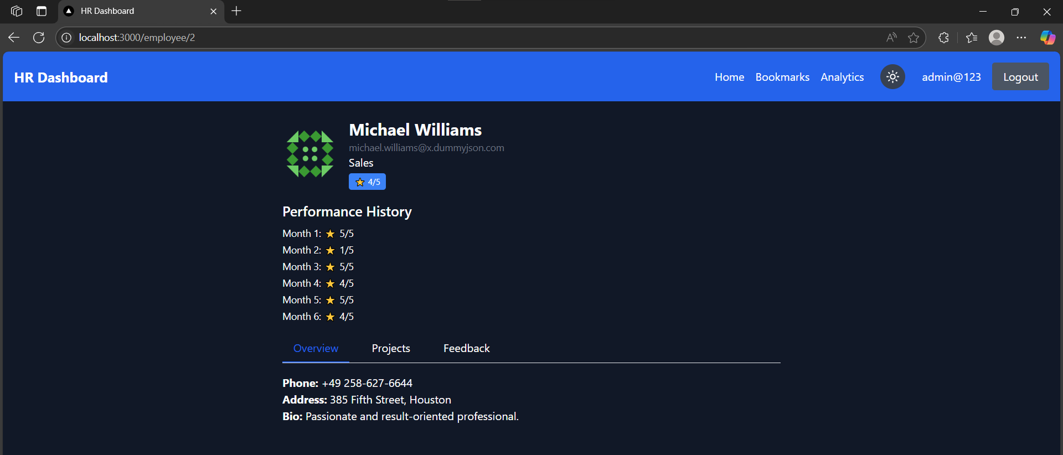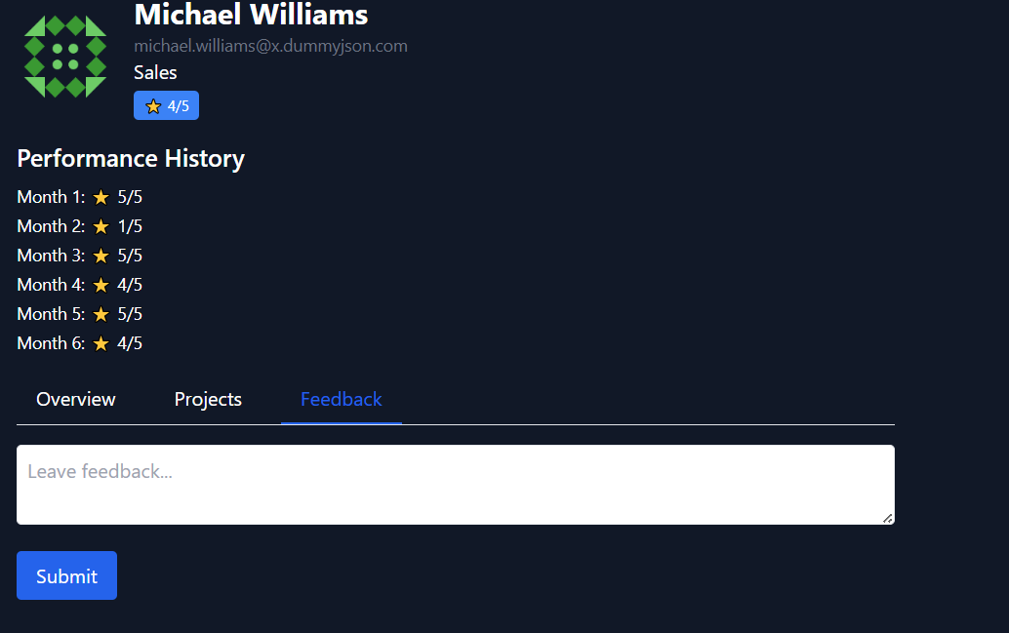->Analytics page:

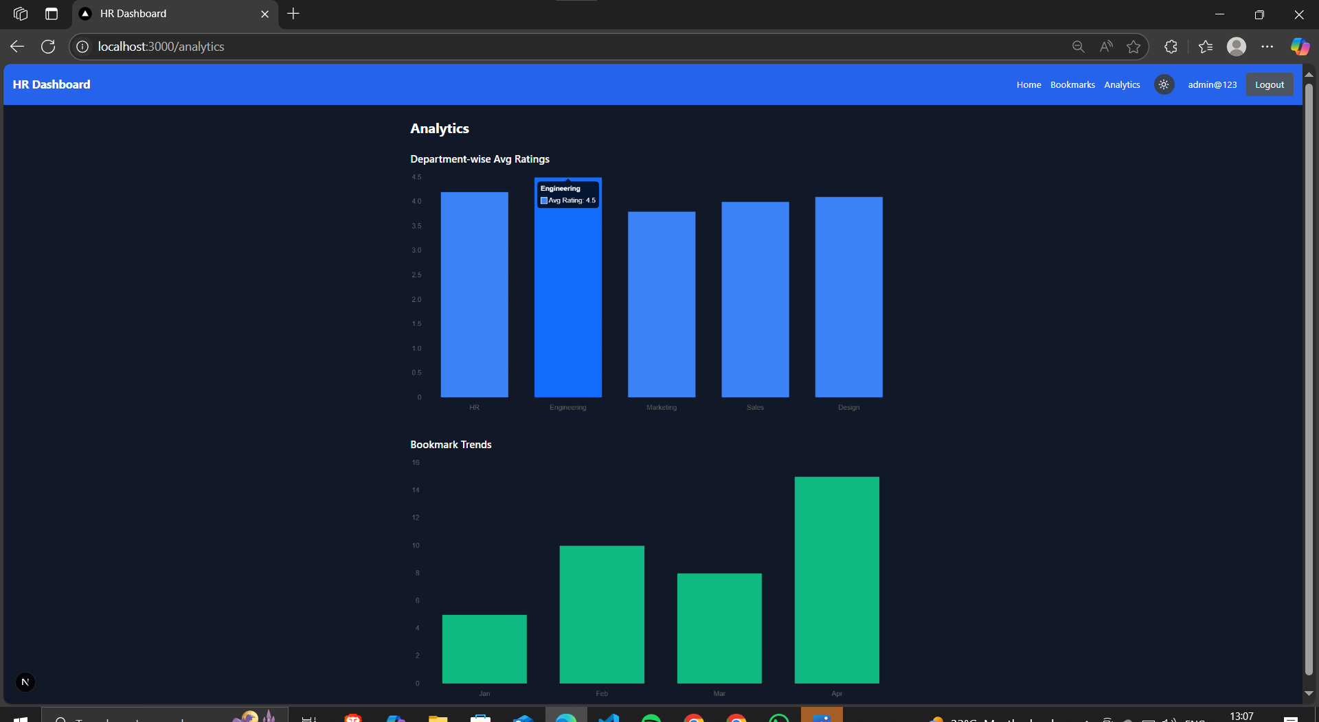REQUIREMENTS ACCORDING TO TASK:

1. 🏠 **Dashboard Homepage (/)->already displayed above**

2. 🔍 **Search & Filter**

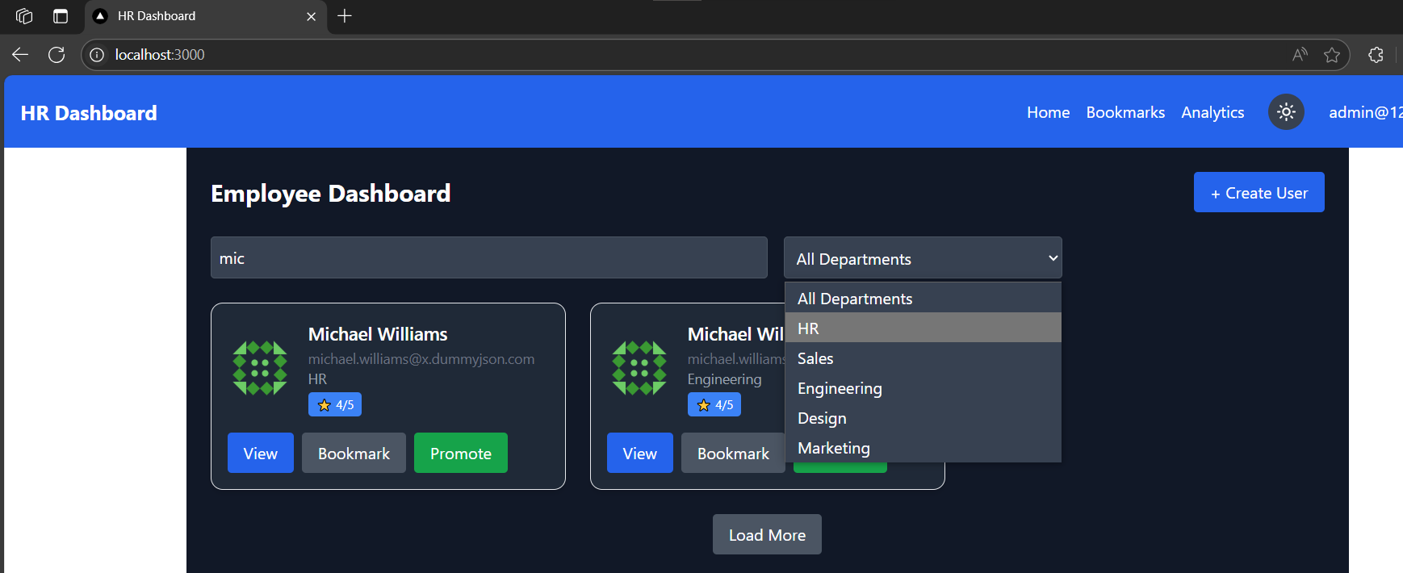3. 👤 **Dynamic User Details Page (/employee/[id])->displayed in the above pictures**

4. 📌 **Bookmark Manager (/bookmarks)**

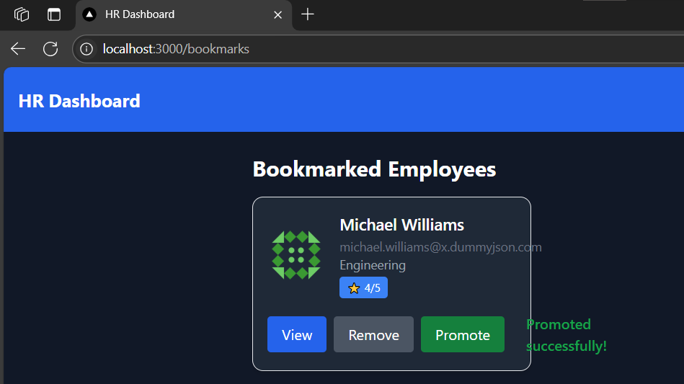5. 📊 **Analytics Page (/analytics)->already displayed in analytics page**

**Dark/Light mode** using Tailwind classes: moon and star icons implemented for dark and light modes

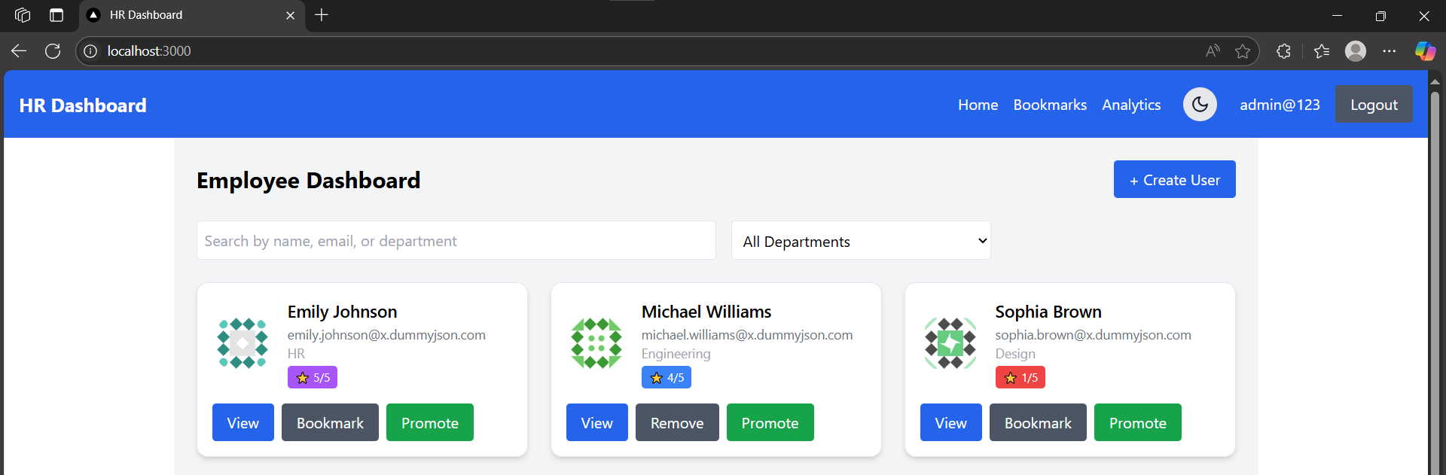

Form handling (e.g., for "Feedback" tab)->already displayed in view page

### **⭐️ Bonus (Extra Points)**

* Add **Authentication** (NextAuth.js or mock login screen)-->displayed above
* Add a “Create User” modal or page with basic form validation--->already displayed above
* Paginate or infinite scroll the main user list-->pagination implemented

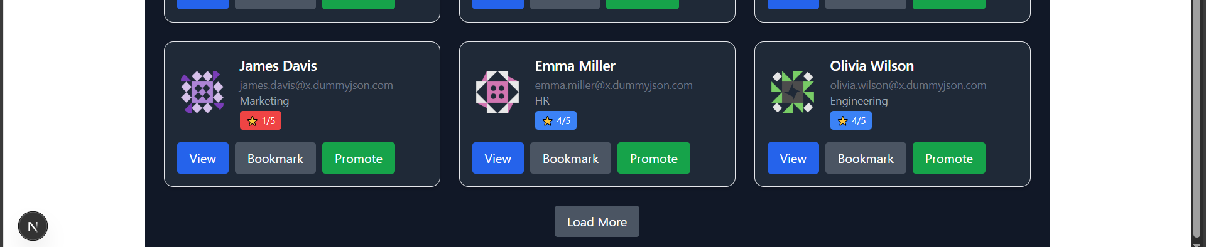

* Animate tab/content transitions (Framer Motion or Tailwind)-->implemented ..view in code
* **ALL THE REQUIREMENTS ACCORDING TO TASK-1 ARE DONE**
* **TO RUN THE CODE USE “npm run dev” IN THE TERMINAL**
* **ALL THE DEPENDENCIES SHOULD BE INSTALLED BEFORE RUNNING THE CODE**